Assignment 1:

Enabled kubernetes in Docker Desktop:

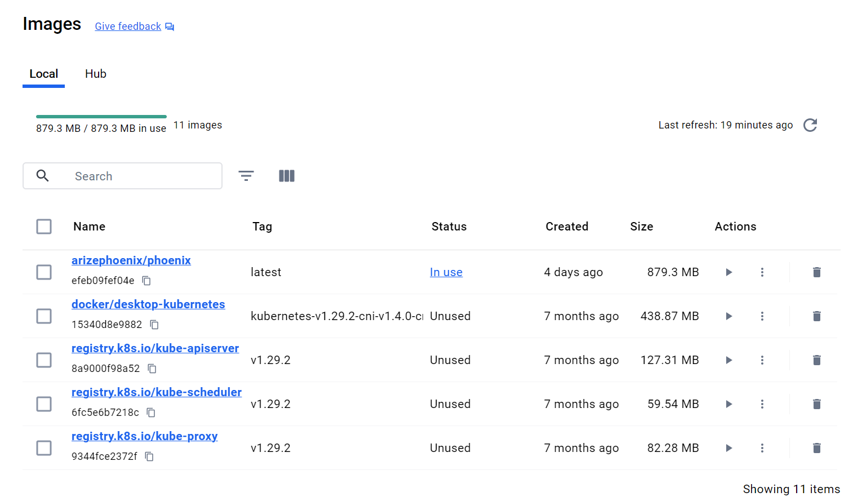

1. Set Up Your Kubernetes Environment:

2. Create a Pod Using the Imperative Method:

3. Access the Pod:

4. Create a Deployment Using the Declarative Method:



5. Scaling the Deployment:



6. Clean Up Resources:

Assignment 2:

1. Create a Secret:

2. Create a Persistent Volume and Persistent Volume Claim:

3. Create a Deployment Using the PVC and Secret:

4. Access the Pods to Verify Configuration:

5. Clean Up Resources:

